Promo 01

Unique registration Link:   
  
<https://us02web.zoom.us/w/81314758372?tk=iF_b3d6hg8AIj6S2voGQ5DJMjGvd8Ap_c6FCxX1AH_Y.DQkAAAAS7ry-5BZ6RDZsVW9fWFFOV3FfNlBrdWFwMVRRAAAAAAAAAAAAAAAAAAAAAAAAAAAAAAAAAAAAAAAAAAA&uuid=WN_AWe5TNXESLqxJF0Dy-rrbA>

✨ Panel Alert! ✨  
 📅 October 22, 2025 | ⏰ 8:00–9:00 PM EST  
 💻 Live on Zoom + Streaming to LinkedIn & Facebook

I’m thrilled to be speaking at the Veterinary Technology & Innovation Panel —  
 “When Tech Helps — and When It Hurts — the Human-Animal Connection.”

We’ll be diving into how technology is reshaping veterinary care — and where we need to pause and preserve the human touch. Topics include:  
 🐾 The benefits of telemedicine and remote monitoring  
 🐾 The risks of over-reliance on automation in client interactions  
 🐾 Balancing efficiency with empathy and connection  
 🐾 Training teams to integrate technology without losing compassion  
 🐾 How tech can boost compliance and patient follow-up

🎟 Complimentary Registration:  
  
 👉 [Register Here](https://us02web.zoom.us/w/81314758372?tk=iF_b3d6hg8AIj6S2voGQ5DJMjGvd8Ap_c6FCxX1AH_Y.DQkAAAAS7ry-5BZ6RDZsVW9fWFFOV3FfNlBrdWFwMVRRAAAAAAAAAAAAAAAAAAAAAAAAAAAAAAAAAAAAAAAAAAA&uuid=WN_AWe5TNXESLqxJF0Dy-rrbA)

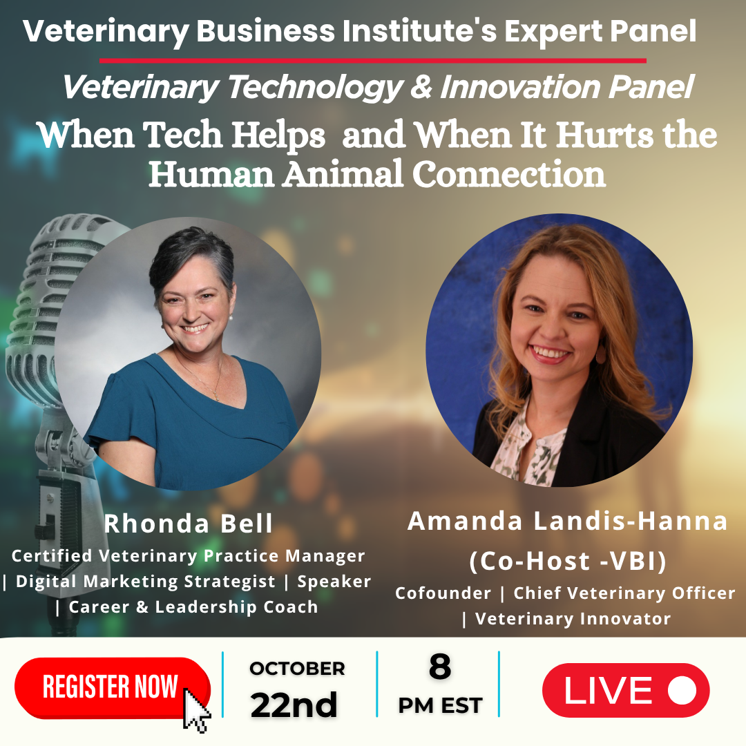

Promo 02

Unique registration Link:   
  
<https://us02web.zoom.us/w/81314758372?tk=iF_b3d6hg8AIj6S2voGQ5DJMjGvd8Ap_c6FCxX1AH_Y.DQkAAAAS7ry-5BZ6RDZsVW9fWFFOV3FfNlBrdWFwMVRRAAAAAAAAAAAAAAAAAAAAAAAAAAAAAAAAAAAAAAAAAAA&uuid=WN_AWe5TNXESLqxJF0Dy-rrbA>

✨ Panel Alert! ✨  
 📅 October 22, 2025 | ⏰ 8:00–9:00 PM EST  
 💻 Live on Zoom + Streaming to LinkedIn & Facebook

I’m excited to join the upcoming Veterinary Technology & Innovation Panel —  
 “When Tech Helps — and When It Hurts — the Human-Animal Connection.”

Together, we’ll explore how technology is transforming veterinary medicine — and how we can keep empathy and connection at the heart of care.

Our discussion will cover:  
 🐾 The benefits of telemedicine and remote monitoring  
 🐾 The risks of over-reliance on automation in client interactions  
 🐾 How to balance efficiency with empathy  
 🐾 Training teams to use tech tools without losing the human touch  
 🐾 Ways technology can strengthen compliance and patient follow-up

🎟 Complimentary Registration:  
  
 👉 [Register Here](https://us02web.zoom.us/w/81314758372?tk=iF_b3d6hg8AIj6S2voGQ5DJMjGvd8Ap_c6FCxX1AH_Y.DQkAAAAS7ry-5BZ6RDZsVW9fWFFOV3FfNlBrdWFwMVRRAAAAAAAAAAAAAAAAAAAAAAAAAAAAAAAAAAAAAAAAAAA&uuid=WN_AWe5TNXESLqxJF0Dy-rrbA)

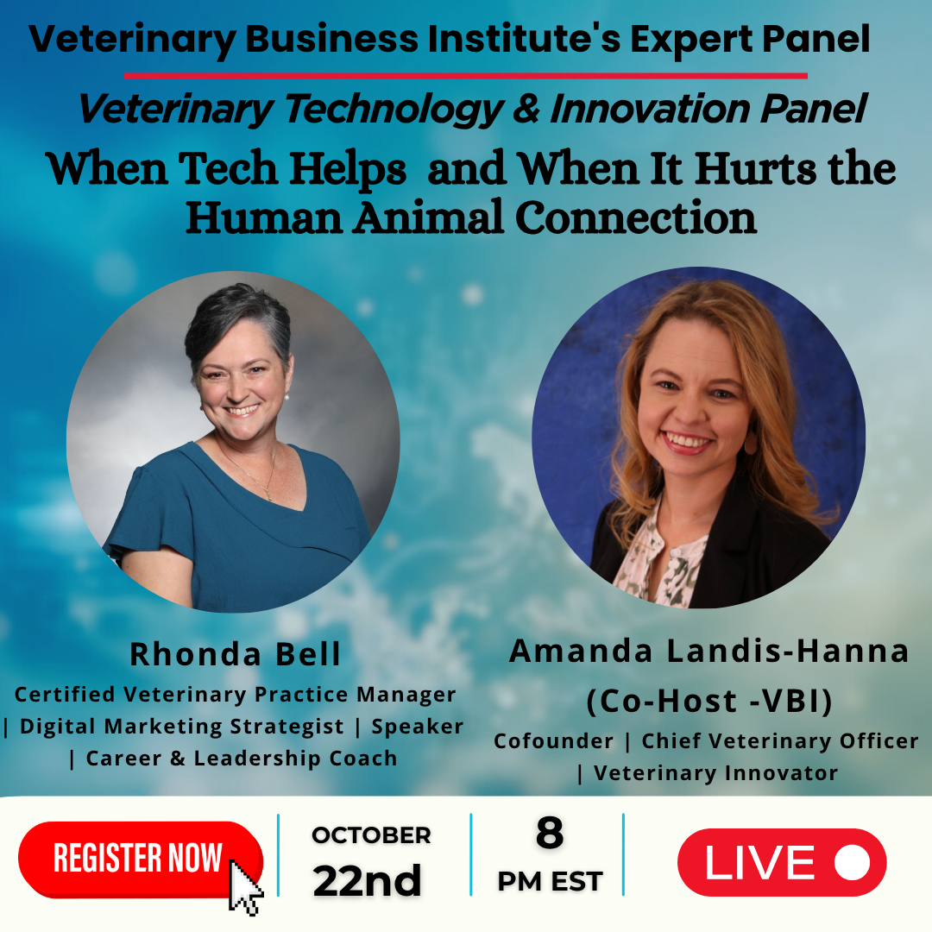

Promo 03

Unique registration Link:   
  
<https://us02web.zoom.us/w/81314758372?tk=iF_b3d6hg8AIj6S2voGQ5DJMjGvd8Ap_c6FCxX1AH_Y.DQkAAAAS7ry-5BZ6RDZsVW9fWFFOV3FfNlBrdWFwMVRRAAAAAAAAAAAAAAAAAAAAAAAAAAAAAAAAAAAAAAAAAAA&uuid=WN_AWe5TNXESLqxJF0Dy-rrbA>

✨ **Join Me for a Critical Conversation on Veterinary Technology** ✨

As technology reshapes our profession, how do we ensure the human-animal bond remains at the heart of our practice?

I am honored to be a panelist for the upcoming discussion: "**When Tech Helps — and When It Hurts — the Human-Animal Connection.**" This is more than a webinar; it's a vital conversation about the future of compassionate and effective veterinary care.

Join us to explore practical strategies for:

🐾 Leveraging telemedicine without losing the personal connection.

🐾 Avoiding the pitfalls of over-automation in client communication.

🐾 Striking the perfect balance between technological efficiency and genuine empathy.

🐾 Empowering your teams to use new tools with confidence and compassion.

📅 Date: Wednesday, October 22, 2025

⏰ Time: 8:00 PM – 9:00 PM EST

💻 Location: Live on Zoom + Streaming to LinkedIn & Facebook

🎟️ Registration is complimentary. Secure your spot below:

👉 [Register Here](https://us02web.zoom.us/w/81314758372?tk=iF_b3d6hg8AIj6S2voGQ5DJMjGvd8Ap_c6FCxX1AH_Y.DQkAAAAS7ry-5BZ6RDZsVW9fWFFOV3FfNlBrdWFwMVRRAAAAAAAAAAAAAAAAAAAAAAAAAAAAAAAAAAAAAAAAAAA&uuid=WN_AWe5TNXESLqxJF0Dy-rrbA)

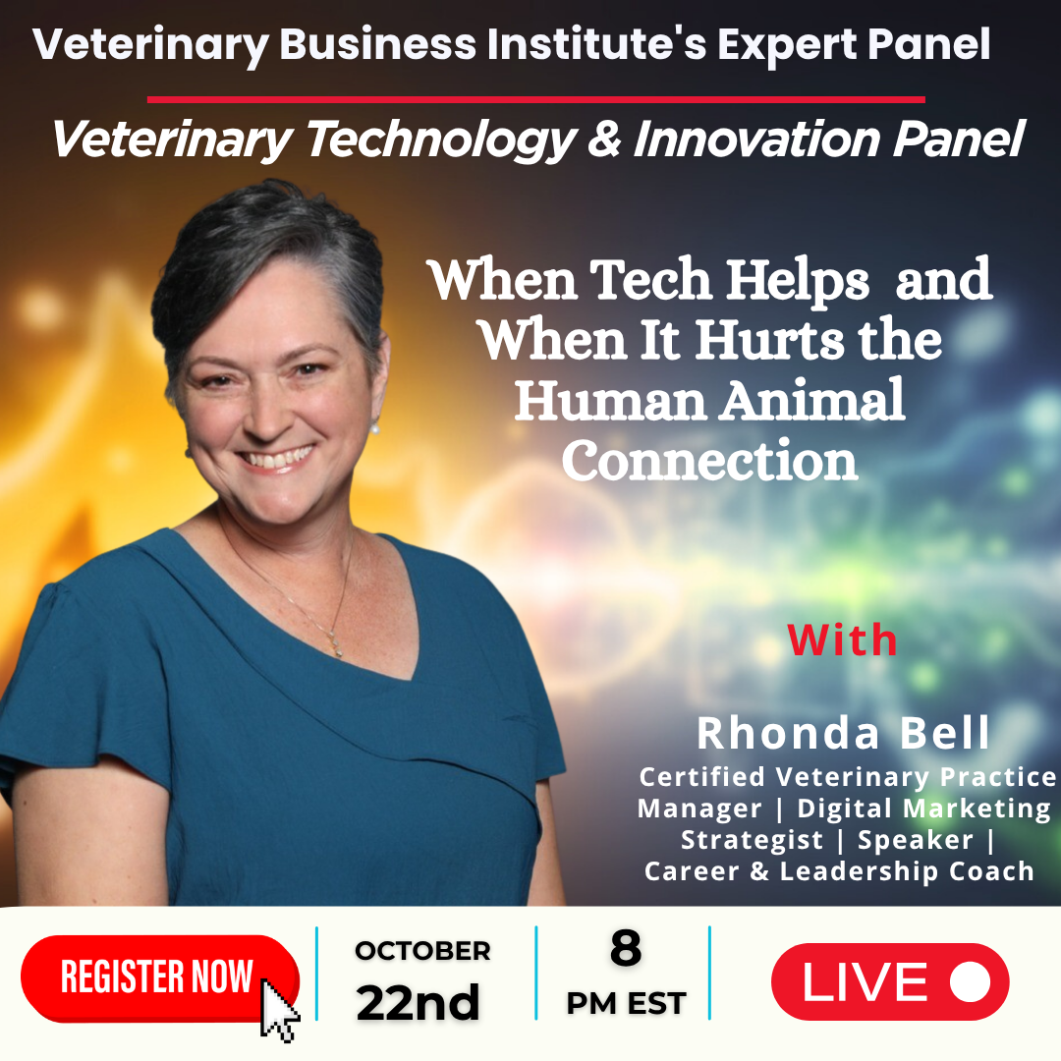

Promo 04

Unique registration Link:   
  
<https://us02web.zoom.us/w/81314758372?tk=iF_b3d6hg8AIj6S2voGQ5DJMjGvd8Ap_c6FCxX1AH_Y.DQkAAAAS7ry-5BZ6RDZsVW9fWFFOV3FfNlBrdWFwMVRRAAAAAAAAAAAAAAAAAAAAAAAAAAAAAAAAAAAAAAAAAAA&uuid=WN_AWe5TNXESLqxJF0Dy-rrbA>

✨ **One More Day to Go! Join Me for This Critical Conversation Tomorrow!** ✨

The countdown is on! Tomorrow, I am honored to be a panelist for the discussion: **"When Tech Helps — and When It Hurts — the Human-Animal Connection."**

As technology continues to reshape the landscape of veterinary medicine, how do we ensure that empathy and the human-animal bond remain at the absolute core of our practice?

There's still time to join us as we explore this vital question and dive into key topics, including:

🐾 The practical benefits of telemedicine and remote monitoring.

🐾 The risks of over-relying on automation for client interactions.

🐾 Strategies to balance technological efficiency with genuine empathy.

🐾 How to empower teams to use new tools without losing the human touch.

📅 Date: Tomorrow, Wednesday, October 22, 2025

⏰ Time: 8:00 PM – 9:00 PM EST

💻 Location: Live on Zoom + Streaming to LinkedIn & Facebook

This discussion is essential for anyone passionate about the future of compassionate and effective veterinary care.

🎟️ Registration is complimentary. Secure your spot for tomorrow's session below:

👉 [Register Here](https://us02web.zoom.us/w/81314758372?tk=iF_b3d6hg8AIj6S2voGQ5DJMjGvd8Ap_c6FCxX1AH_Y.DQkAAAAS7ry-5BZ6RDZsVW9fWFFOV3FfNlBrdWFwMVRRAAAAAAAAAAAAAAAAAAAAAAAAAAAAAAAAAAAAAAAAAAA&uuid=WN_AWe5TNXESLqxJF0Dy-rrbA)

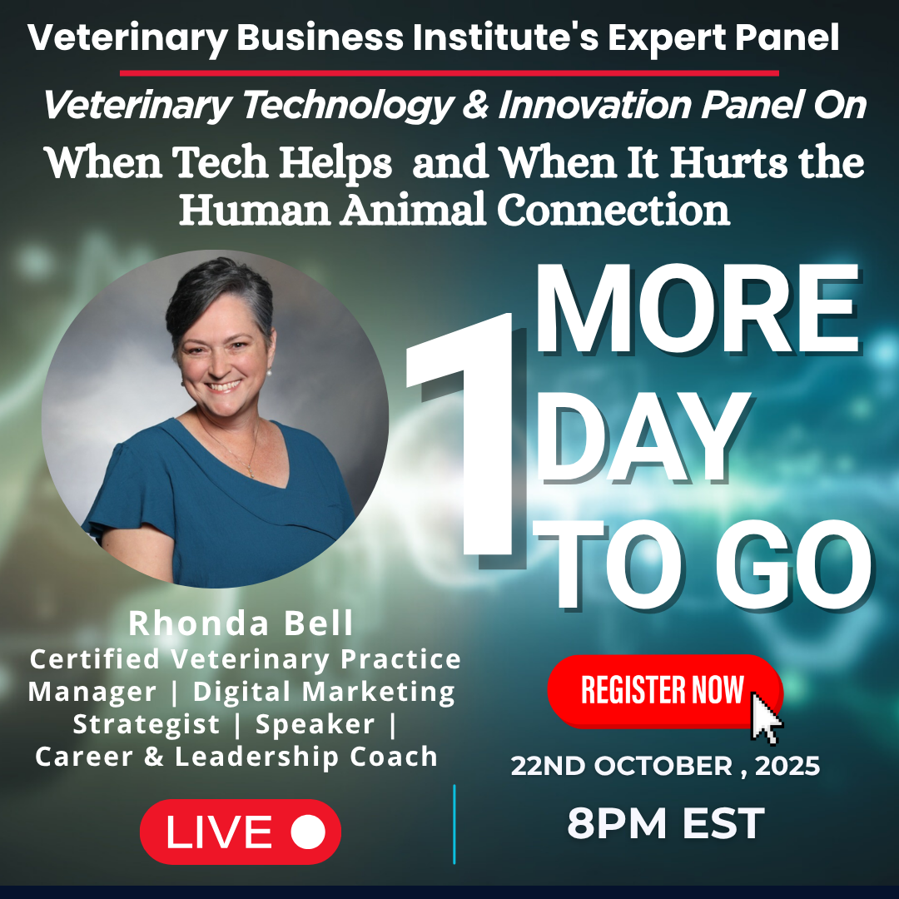

Promo 05

Unique registration Link:   
  
<https://us02web.zoom.us/w/81314758372?tk=iF_b3d6hg8AIj6S2voGQ5DJMjGvd8Ap_c6FCxX1AH_Y.DQkAAAAS7ry-5BZ6RDZsVW9fWFFOV3FfNlBrdWFwMVRRAAAAAAAAAAAAAAAAAAAAAAAAAAAAAAAAAAAAAAAAAAA&uuid=WN_AWe5TNXESLqxJF0Dy-rrbA>

✨ **It's Happening Tonight! Final Call to Register!** ✨

📅 When: Tonight, October 22, 2025 | ⏰ 8:00 PM – 9:00 PM EST

💻 Where: Live on Zoom + Streaming to LinkedIn & Facebook

The day has arrived! I’m incredibly excited to join the **Veterinary Technology & Innovation Panel** tonight for our discussion — **“When Tech Helps — and When It Hurts — the Human-Animal Connection.”**

This is your final chance to join us live. Together, we’ll explore how technology is transforming veterinary medicine and, most importantly, how we can keep empathy and connection at the heart of care.

For anyone who missed it, our discussion will cover:

🐾 The benefits of telemedicine and remote monitoring

🐾 The risks of over-reliance on automation in client interactions

🐾 How to balance efficiency with empathy

🐾 Training teams to use tech tools without losing the human touch

🐾 Ways technology can strengthen compliance and patient follow-up

If this conversation is important to you, don't miss out.

🎟️ Registration is complimentary and provides immediate access. Sign up now to join us tonight!

👉 [Register Here](https://us02web.zoom.us/w/81314758372?tk=iF_b3d6hg8AIj6S2voGQ5DJMjGvd8Ap_c6FCxX1AH_Y.DQkAAAAS7ry-5BZ6RDZsVW9fWFFOV3FfNlBrdWFwMVRRAAAAAAAAAAAAAAAAAAAAAAAAAAAAAAAAAAAAAAAAAAA&uuid=WN_AWe5TNXESLqxJF0Dy-rrbA)

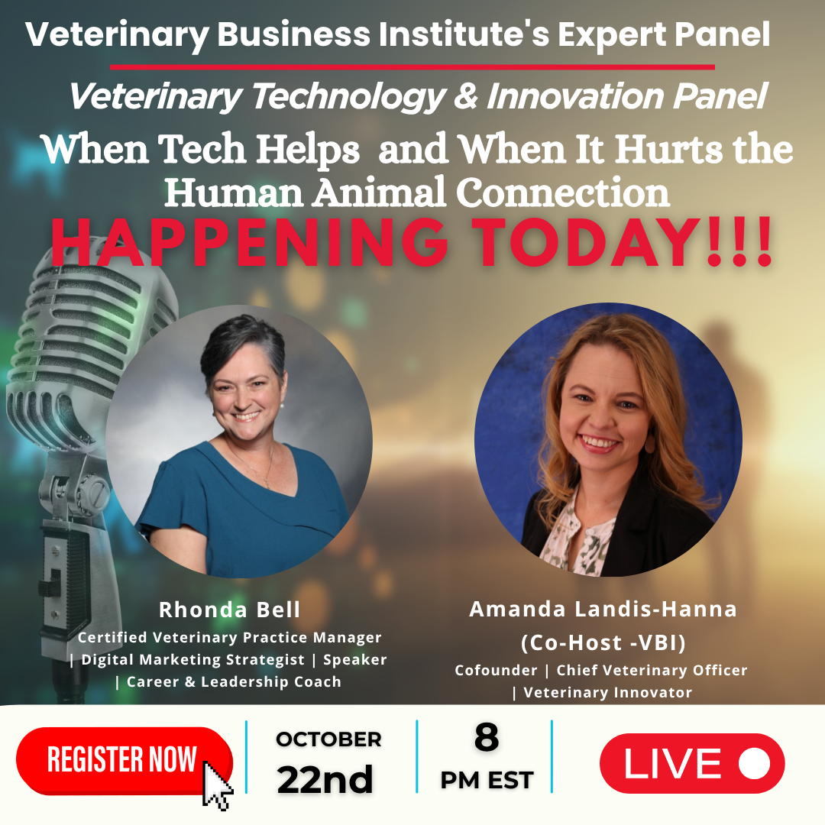

Email Promotion

**Subject:** Join Me Tomorrow for the Veterinary Technology & Innovation Panel 🐾

Hi there,

✨ **Just one day to go!** ✨

I’m excited to invite you to join me for the **Veterinary Technology & Innovation Panel** —  
 **“When Tech Helps — and When It Hurts — the Human-Animal Connection.”**

📅 **Date:** October 22, 2025  
 ⏰ **Time:** 8:00–9:00 PM EST  
 💻 **Where:** Live on Zoom (also streaming to LinkedIn & Facebook)

This engaging discussion will explore how technology is reshaping veterinary medicine — and how we can preserve empathy, trust, and connection at the heart of care.

We’ll be covering:  
 🐾 The benefits of telemedicine and remote monitoring  
 🐾 The risks of over-reliance on automation in client interactions  
 🐾 Balancing efficiency with empathy  
 🐾 Training teams to use tech tools without losing the human touch  
 🐾 How technology can strengthen compliance and patient follow-up

🎟 **Complimentary Registration:** 👉 [Register Here](https://us02web.zoom.us/w/81314758372?tk=iF_b3d6hg8AIj6S2voGQ5DJMjGvd8Ap_c6FCxX1AH_Y.DQkAAAAS7ry-5BZ6RDZsVW9fWFFOV3FfNlBrdWFwMVRRAAAAAAAAAAAAAAAAAAAAAAAAAAAAAAAAAAAAAAAAAAA&uuid=WN_AWe5TNXESLqxJF0Dy-rrbA)

I’d love for you to join the conversation and share your perspective on how we can blend innovation with compassion in veterinary practice.